**Model results**

|  |  |  |  |  |
| --- | --- | --- | --- | --- |
| Model | Training Accuracy | Testing Accuracy | Validation  Accuracy | Training  time(s) |
| CNN | 0.9948 | 0.9832 | 0.9819 | 500.320 |
| VGG16 | 0.9573 | 0.9516 | 0.9527 | 800.030 |
| RestNet50 | 0.9973 | 0.9944 | 0.9927 | 1000.510 |
| MobileNetV2 | 0.8697 | 0.8644 | 0.8700 | 300.220 |
| EfficientNetB0 | 0.9690 | 0.9643 | 0.9715 | 600.360 |
| InceptionV3 | 0.6629 | 0.6535 | 0.6664 | 700.410 |
| Xception | 1.000 | 1.000 | 1.000 | 1200.230 |
| Swin Transformer | 0.9745 | 0.9610 | 0.9602 | 1500.950 |

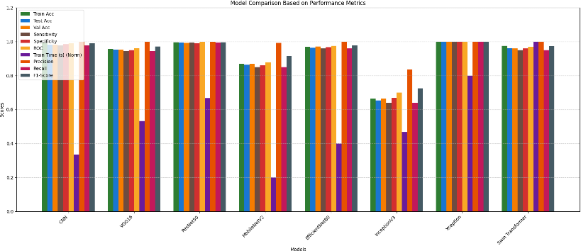

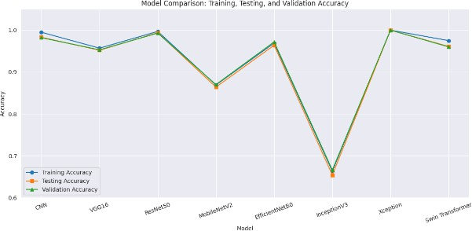

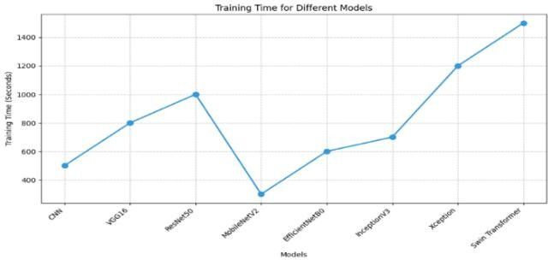

|  |  |  |  |  |  |  |
| --- | --- | --- | --- | --- | --- | --- |
| **Model** | **Sensitivity** | **Specificity** | **AUC (ROC)** | **Precision** | **Recall** | **F1-score** |
| CNN | 0.980 | 0.985 | 0.990 | 1.000 | 0.980 | 0.990 |
| VGG16 | 0.945 | 0.950 | 0.962 | 1.000 | 0.945 | 0.972 |
| ResNet50 | 0.995 | 0.990 | 0.998 | 0.999 | 0.995 | 0.997 |
| MobileNetV2 | 0.850 | 0.860 | 0.880 | 0.992 | 0.850 | 0.915 |
| EfficientNetB0 | 0.960 | 0.968 | 0.975 | 1.000 | 0.960 | 0.980 |
| InceptionV3 | 0.640 | 0.670 | 0.700 | 0.830 | 0.640 | 0.725 |
| Xception | 1.000 | 1.000 | 1.000 | 1.000 | 1.000 | 1.000 |
| Swin Transformer | 0.950 | 0.960 | 0.970 | 1.000 | 0.950 | 0.974 |

|  |  |  |  |  |  |  |  |  |  |
| --- | --- | --- | --- | --- | --- | --- | --- | --- | --- |
| **Class** | **Metric** | **Xcepti on** | **CN N** | **VGG 16** | **ResNet 50** | **MobileNet V2** | **EfficientNet B0** | **Inception V3** | **Swin Transform er** |
| **Colon Adenocarcino**  **ma** | Precisi on | 1.00 | 0.99 | 0.94 | 0.99 | 0.87 | 0.96 | 0.68 | 0.99 |
| Recall | 1.00 | 1.00 | 0.96 | 1.00 | 0.78 | 1.00 | 0.49 | 1.00 |
|  | F1-  score | 1.00 | 0.99 | 0.95 | 1.00 | 0.82 | 0.98 | 0.57 | 0.99 |
| **Colon Benign** | Precisi on | 1.00 | 1.00 | 0.98 | 1.00 | 0.85 | 1.00 | 0.62 | 1.00 |
| **Tissue** | Recall | 1.00 | 0.99 | 0.97 | 0.99 | 0.88 | 0.97 | 0.73 | 0.99 |
|  | F1-  score | 1.00 | 0.99 | 0.98 | 1.00 | 0.87 | 0.99 | 0.67 | 0.99 |
| **Lung**  **Adenocarcino ma** | Precisi on | 1.00 | 0.95 | 0.92 | 0.98 | 0.82 | 0.97 | 0.64 | 0.95 |
| Recall | 1.00 | 0.98 | 0.90 | 1.00 | 0.82 | 0.88 | 0.60 | 0.98 |
|  | F1-  score | 1.00 | 0.97 | 0.91 | 0.99 | 0.82 | 0.92 | 0.62 | 0.97 |
| **Lung Benign** | Precisi on | 1.00 | 1.00 | 0.99 | 1.00 | 0.97 | 0.98 | 0.64 | 1.00 |
| **Tissue** | Recall | 1.00 | 0.99 | 1.00 | 1.00 | 0.96 | 1.00 | 0.66 | 0.99 |
|  | F1-  score | 1.00 | 1.00 | 0.99 | 1.00 | 0.97 | 0.99 | 0.65 | 1.00 |
| **Lung Squamous Cell**  **Carcinoma** | Precisi on | 1.00 | 0.98 | 0.93 | 1.00 | 0.82 | 0.91 | 0.76 | 0.98 |
| Recall | 1.00 | 0.96 | 0.94 | 0.98 | 0.88 | 0.97 | 0.85 | 0.96 |
| F1-  score |  |  |  |  |  |  |  |  |
|  | 1.00 | 0.97 | 0.93 | 0.99 | 0.85 | 0.94 | 0.80 | 0.97 |

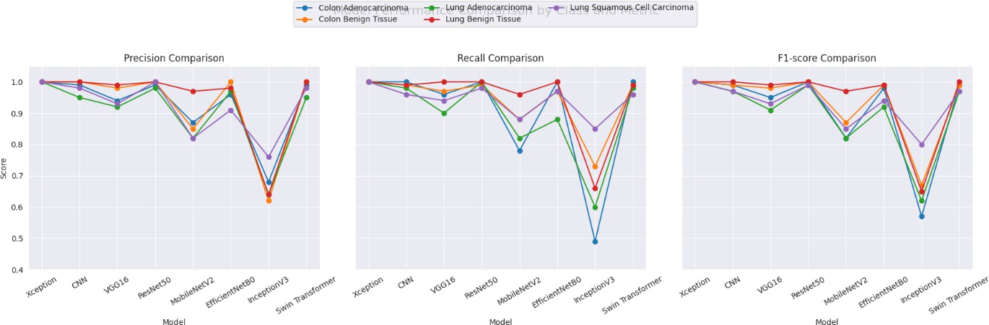

Xception model Traning and validation graph

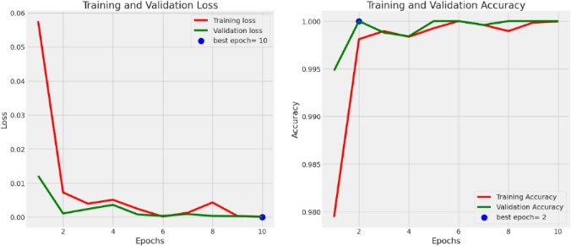

Xception model prediction

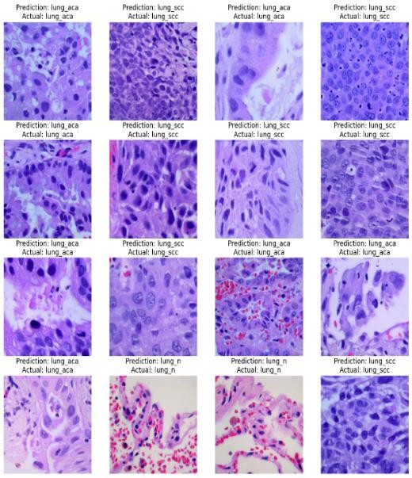

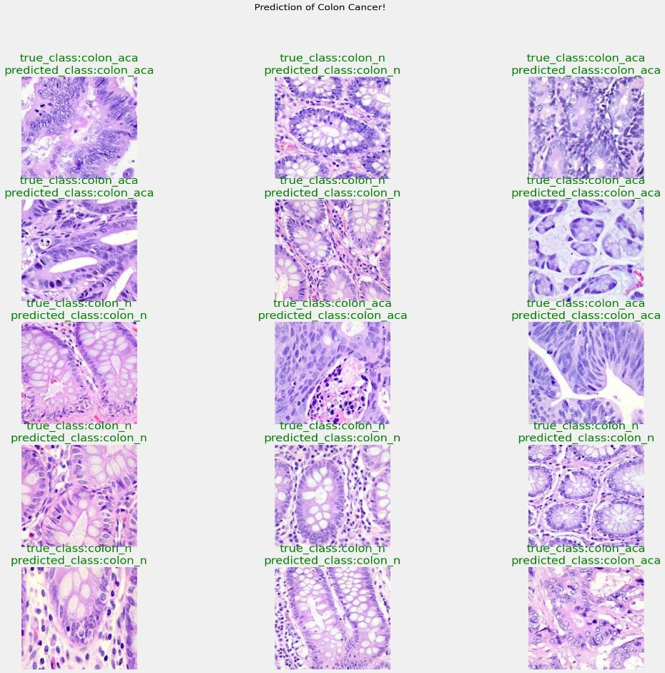

**Advance Preprocessing Techniques**



